Riphah International University
Gulberg Green Campus Islamabad
Faculty of Computing (WISH)



Name: Anisha Rehmat.
Sap ID: 78019.
Submitted To: Mam Nayab Khalid
Submitted by: Anisha Rehmat.

Supervision and Coordination

Miss Shazwa Tun Naeem
Lecturer
Faculty of Computing

Lab Designers

Miss Nayab Khalid
Teaching Fellow
Faculty of Computing

Lab Task 2

Learning Outcomes:
· Classes and Objects
· Defining a Class
· Data Members and Member Functions
· Access Modifiers
· Constructors
· Array of Object

LAB TASKS

Task 1 — Employee Records
Create an Employee class with public members name, employeeID and salary. Implement both a default constructor and a parameterized constructor. Create two objects and display their information.
Extension: Add a function that increases salary by a given percentage.
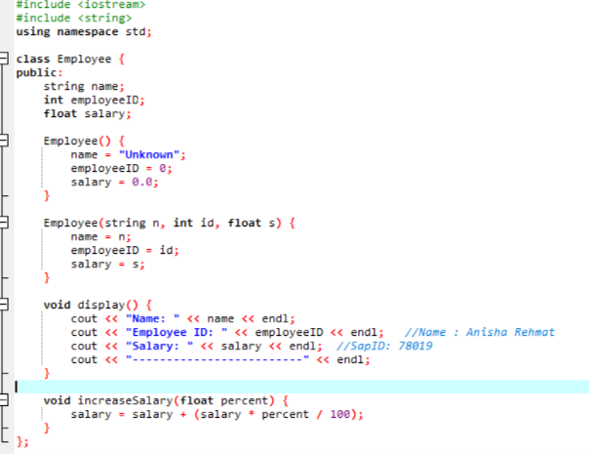
Code:-

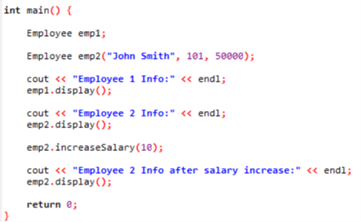

Output:-
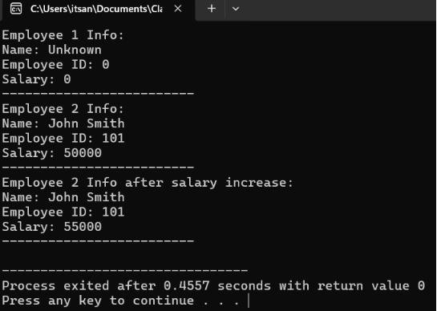

Task 2 — Student Result System
Design a Student Result System using a class named Student. Store public members name, rollNo and marks for three subjects. Use a parameterized constructor and member functions to calculate total, average and grade. Create an array of at least three Student objects and display the result of every student.
Requirements:
· Use public data members.
· Use a constructor to initialize each student.
· Use separate functions for total and average.
· Assign a grade based on average.
· Use an array of objects.
· Display a neat result for all students.
Code:-
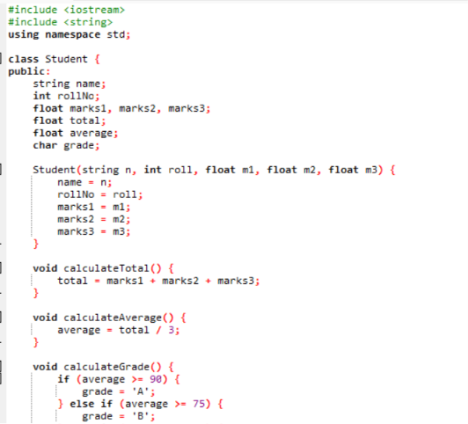
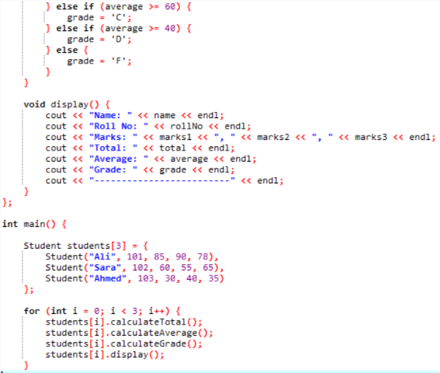
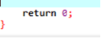
Output:-
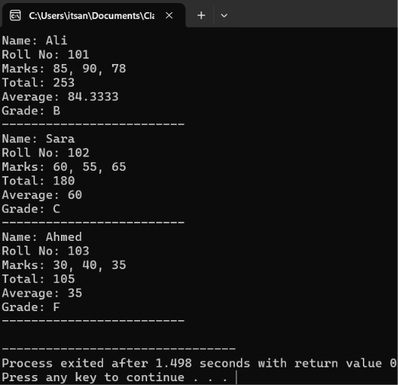

Task 3 — Bank Account Management System
· Create an Account class with:
· Account holder name, account number, and balance.
· Use appropriate access specifiers.
· Implement a default constructor and a parameterized constructor.
· Create objects for 3 accounts.
· Create functions to deposit, withdraw, and display account information.
· Display the final balance of each account.
Code:-
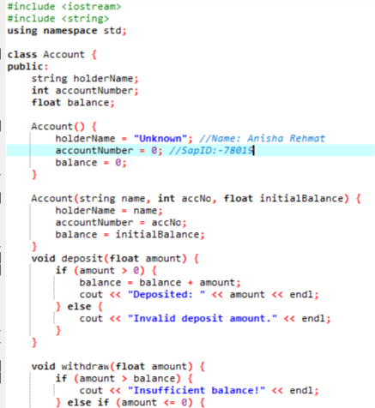

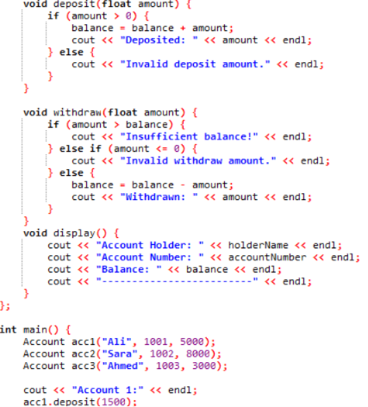
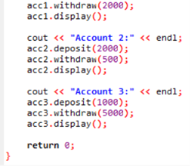

Output:-


